**Task 5. Password Policy:**

* 1. Modify the account password policy to enhance security.
  2. Enforce specific password requirements.

Steps to modify account password policy to enhance security:

1. In the IAM console dashboard go to account settings. And click on “Edit” password policy.

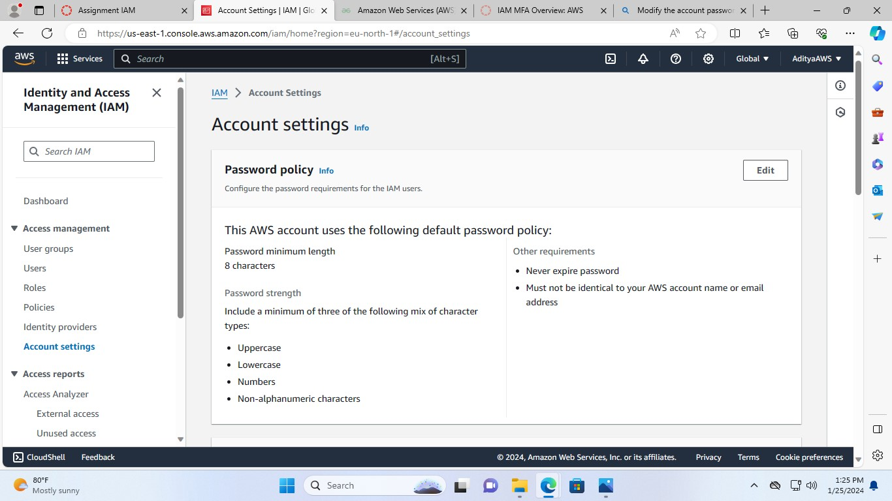

1. Now, select custom and do the changes.

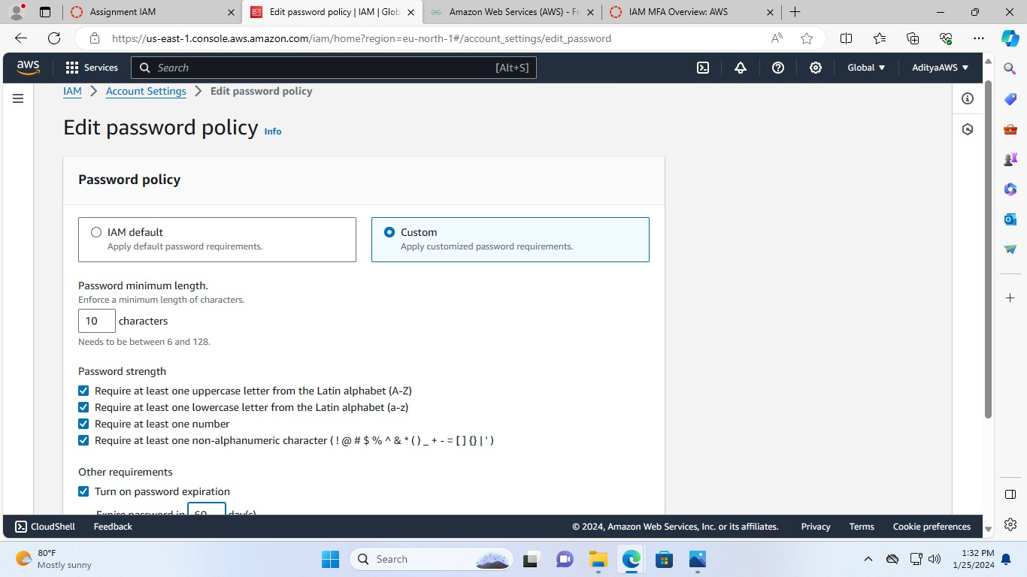

**I have enforced a minimum length of password to 10 characters, for the password strength checked all the boxes, and in other requirements I have turned on password expiration so, the password will expire in 60 days.**

1. Then, click Save changes to apply the change.

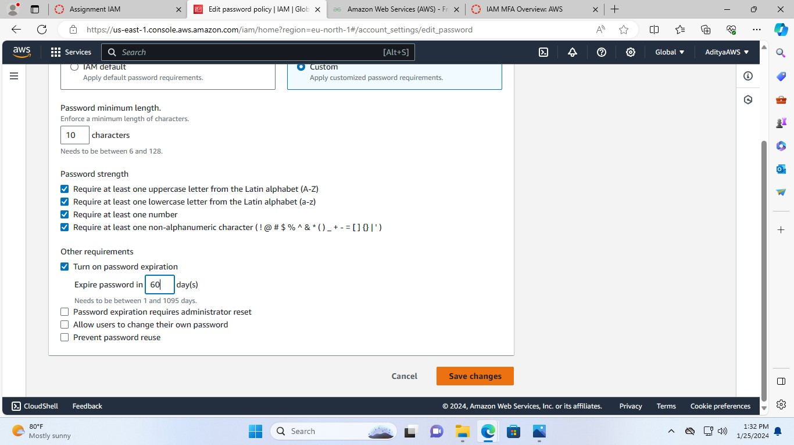

Hence, the password policy is modified successfully.

